**Theme: Access to Clean Water in Rural African Communities**

**"Quenching Thirst: The Struggle for Clean Water in Rural Africa"**

**Introduction**

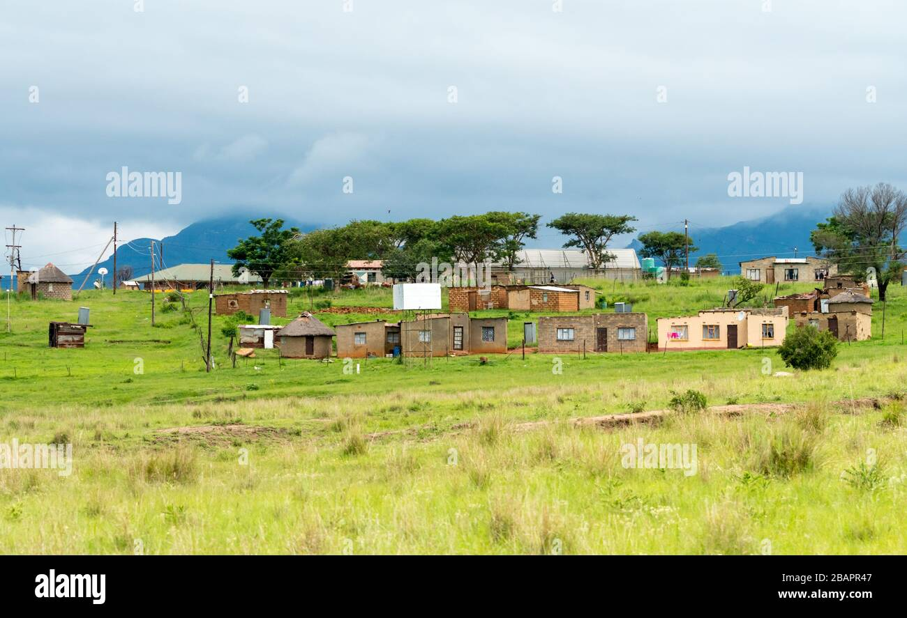

"In many rural African communities, access to clean and safe drinking water remains a daily struggle. Despite progress in other areas, water scarcity continues to be a pressing issue."

**The Journey**

* 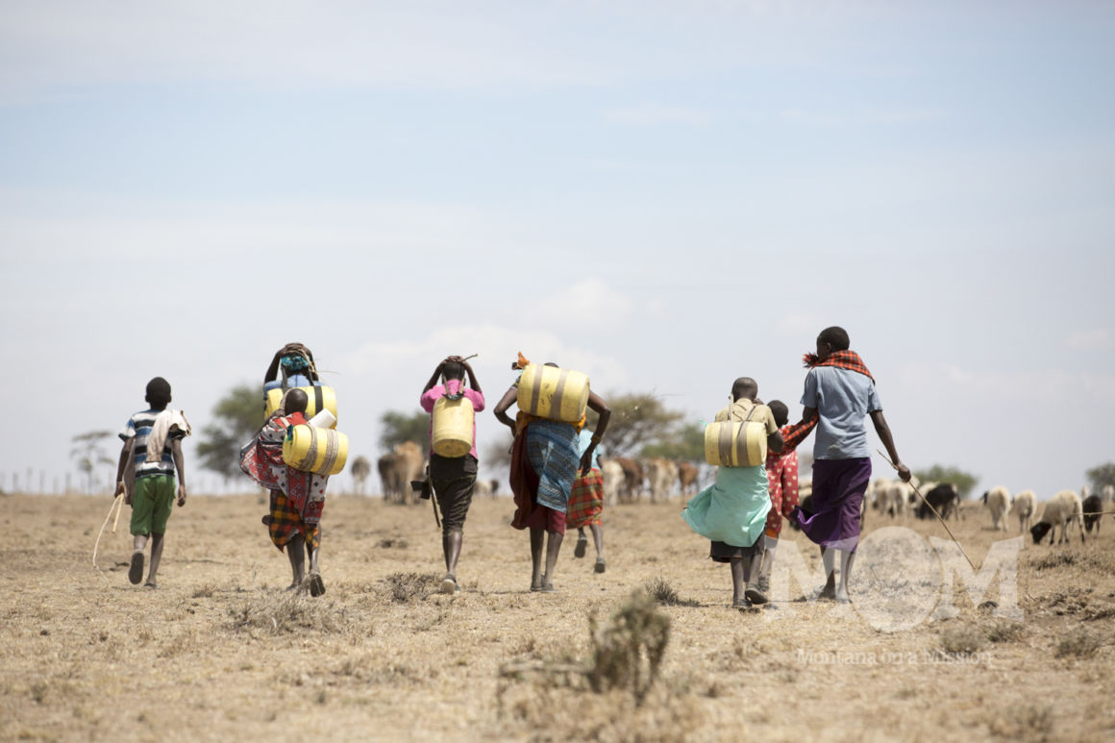
* "Every day, women and children embark on long journeys to fetch water, often from sources that are unsafe. These journeys take hours and consume energy that could be spent on education or economic activities."

**The Source**

* 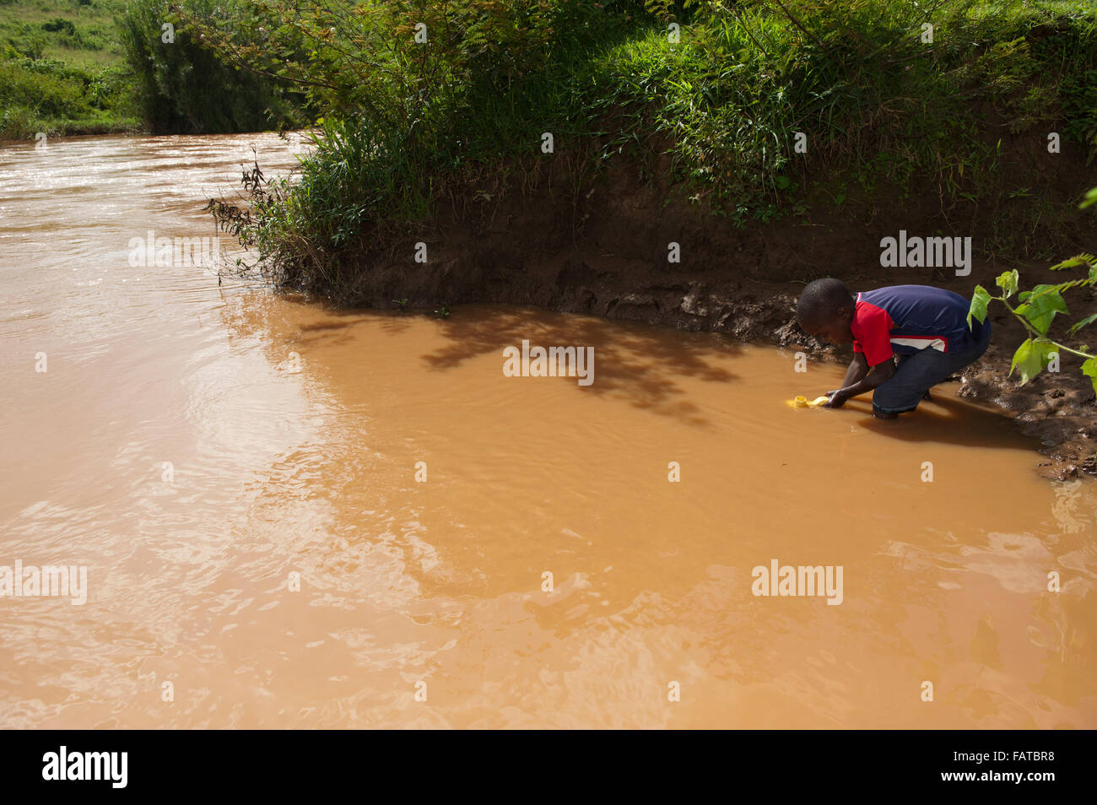.
* "Many water sources in rural Africa are unprotected and contaminated, posing serious health risks. Without alternative options, communities are forced to rely on these unsafe water supplies."

**The Consequence**

* 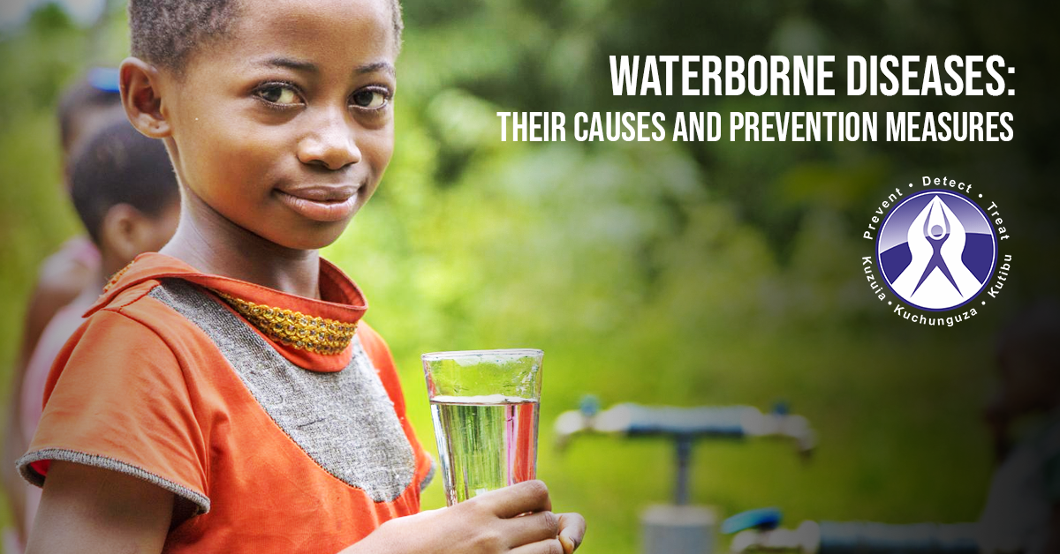
* "Unsafe water leads to waterborne diseases like cholera, dysentery, and typhoid, which claim thousands of lives every year in Africa. Lack of access to clean water affects the health and well-being of entire communities."

**The Solution**

* .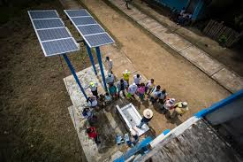
* "Innovative solutions like boreholes, solar-powered pumps, and rainwater harvesting systems are providing clean water to rural communities. These solutions are not only life-saving but also empowering, enabling people to lead healthier and more productive lives."

**The Impact**

* 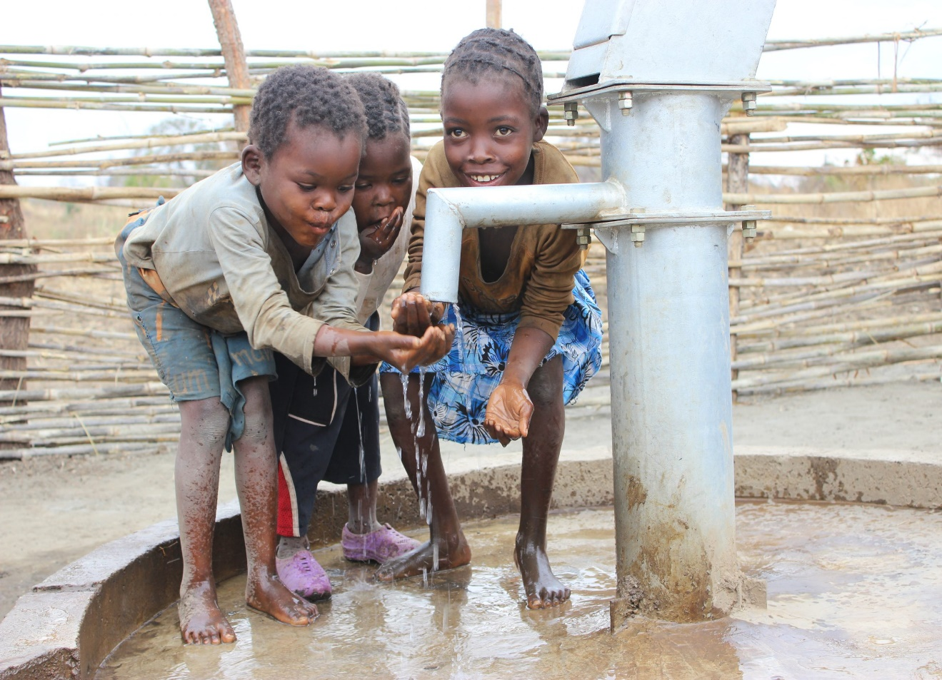
* "Clean water brings hope and opportunity. Children can focus on their education, women have more time for income-generating activities, and the overall health of the community improves."

**The Future**

* 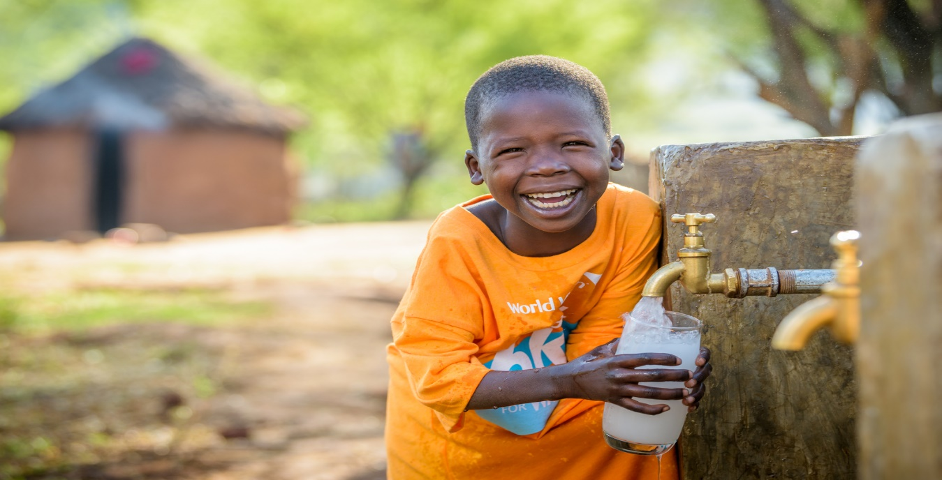
* "The future of Africa depends on sustainable solutions to water scarcity. By working together, communities can overcome the challenges of water access and build a brighter, healthier future."

**Conclusion**

* 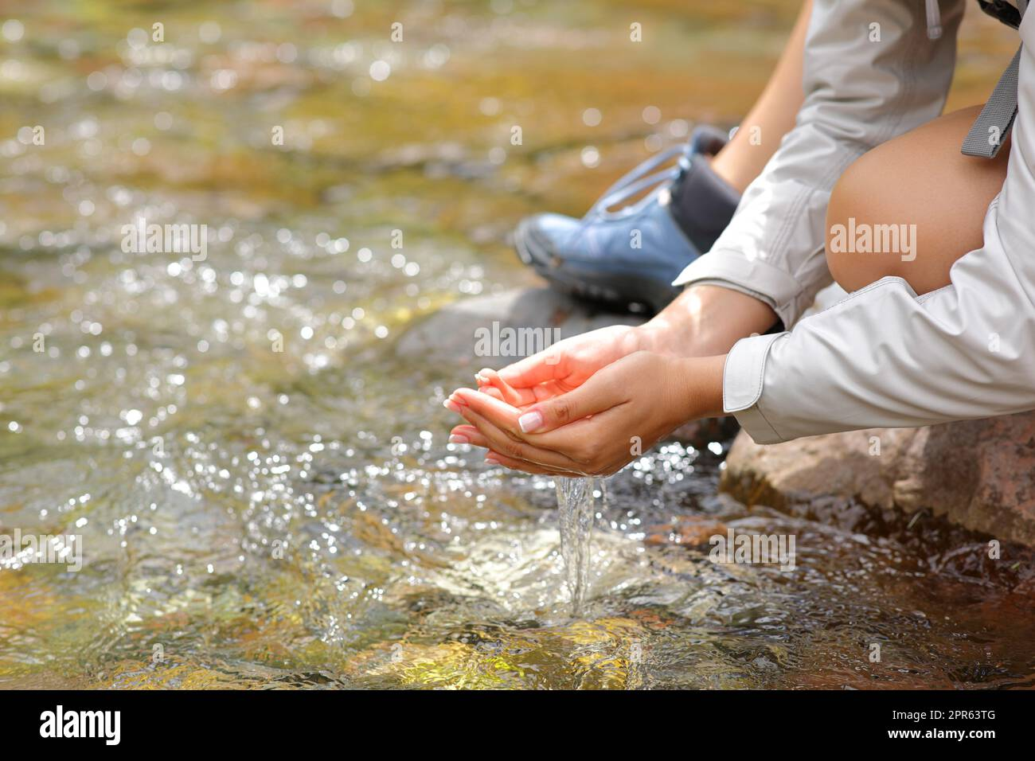
* "Water is life. Ensuring that every community has access to clean water is a fundamental step toward achieving health, equality, and prosperity across Africa."